**LaGuardia Community College – Last Update**

08

**Fall**

Part 1: Introduction

Dr. Andi Toce

Lecture Notes for MAC 101 (Introduction to Computer Science)

Last Update: June 20, 16

Table of Contents

1. What is Computer Science 2

2. Computer Science Careers 3

3. What is Programming and C++ 5

4. Getting Started with C++ 6

# What is Computer Science

There is no clear definition of Computer Science. Different sources give different definitions of Computer Science. Below are a few definitions taken from various university websites.

**George Washington University** [**http://www.seas.gwu.edu/~simhaweb/misc/cscareers.html**](http://www.seas.gwu.edu/~simhaweb/misc/cscareers.html)

What exactly is Computer Science?

Computer Science is the science of using computers to solve problems. Mostly, this involves designing software (computer programs) and addressing fundamental scientific questions about the nature of computation but also involves many aspects of hardware and architecting the large computer systems that form the infrastructure of commercial and government enterprises. Computer scientists work in many different ways: pen-and-paper theoretical work on the foundations and fundamentals, programming work at the computer and collaborative teamwork in doing research and solving problems.

|  |
| --- |
|  |

What Computer Science is not ...

Computer Science is not about using software, such as spreadsheets (like Excel), word processors (like Word) or image tools (like Photoshop). Many software packages are complicated to master (such as Photoshop or Excel) and it is true that many jobs depend on expertise in using such tools, but computer science is not about using the tools. It is not about expertise in computer games, it is not about writing content in websites, and it is not about not about assembling computers or knowing which computers are best buys. Edsger Dijkstra, a famous award-winning computer scientist once said, "Computer Science is no more about computers than Astronomy is about telescopes". Computer Science is about the principles behind building the above software packages, about the algorithms used in computer games, about the technology behind the Internet and about the architecture of computing devices.

**Michigan Technological University** [**http://www.cs.mtu.edu/~john/whatiscs.html**](http://www.cs.mtu.edu/~john/whatiscs.html)

Computer science is a discipline that spans theory and practice. It requires thinking both in abstract terms and in concrete terms. The practical side of computing can be seen everywhere. Nowadays, practically everyone is a computer user, and many people are even computer programmers. Getting computers to do what you want them to do requires intensive hands-on experience. But computer science can be seen on a higher level, as a science of problem solving. Computer scientists must be adept at modeling and analyzing problems. They must also be able to design solutions and verify that they are correct. Problem solving requires precision, creativity, and careful reasoning.

# Computer Science Careers

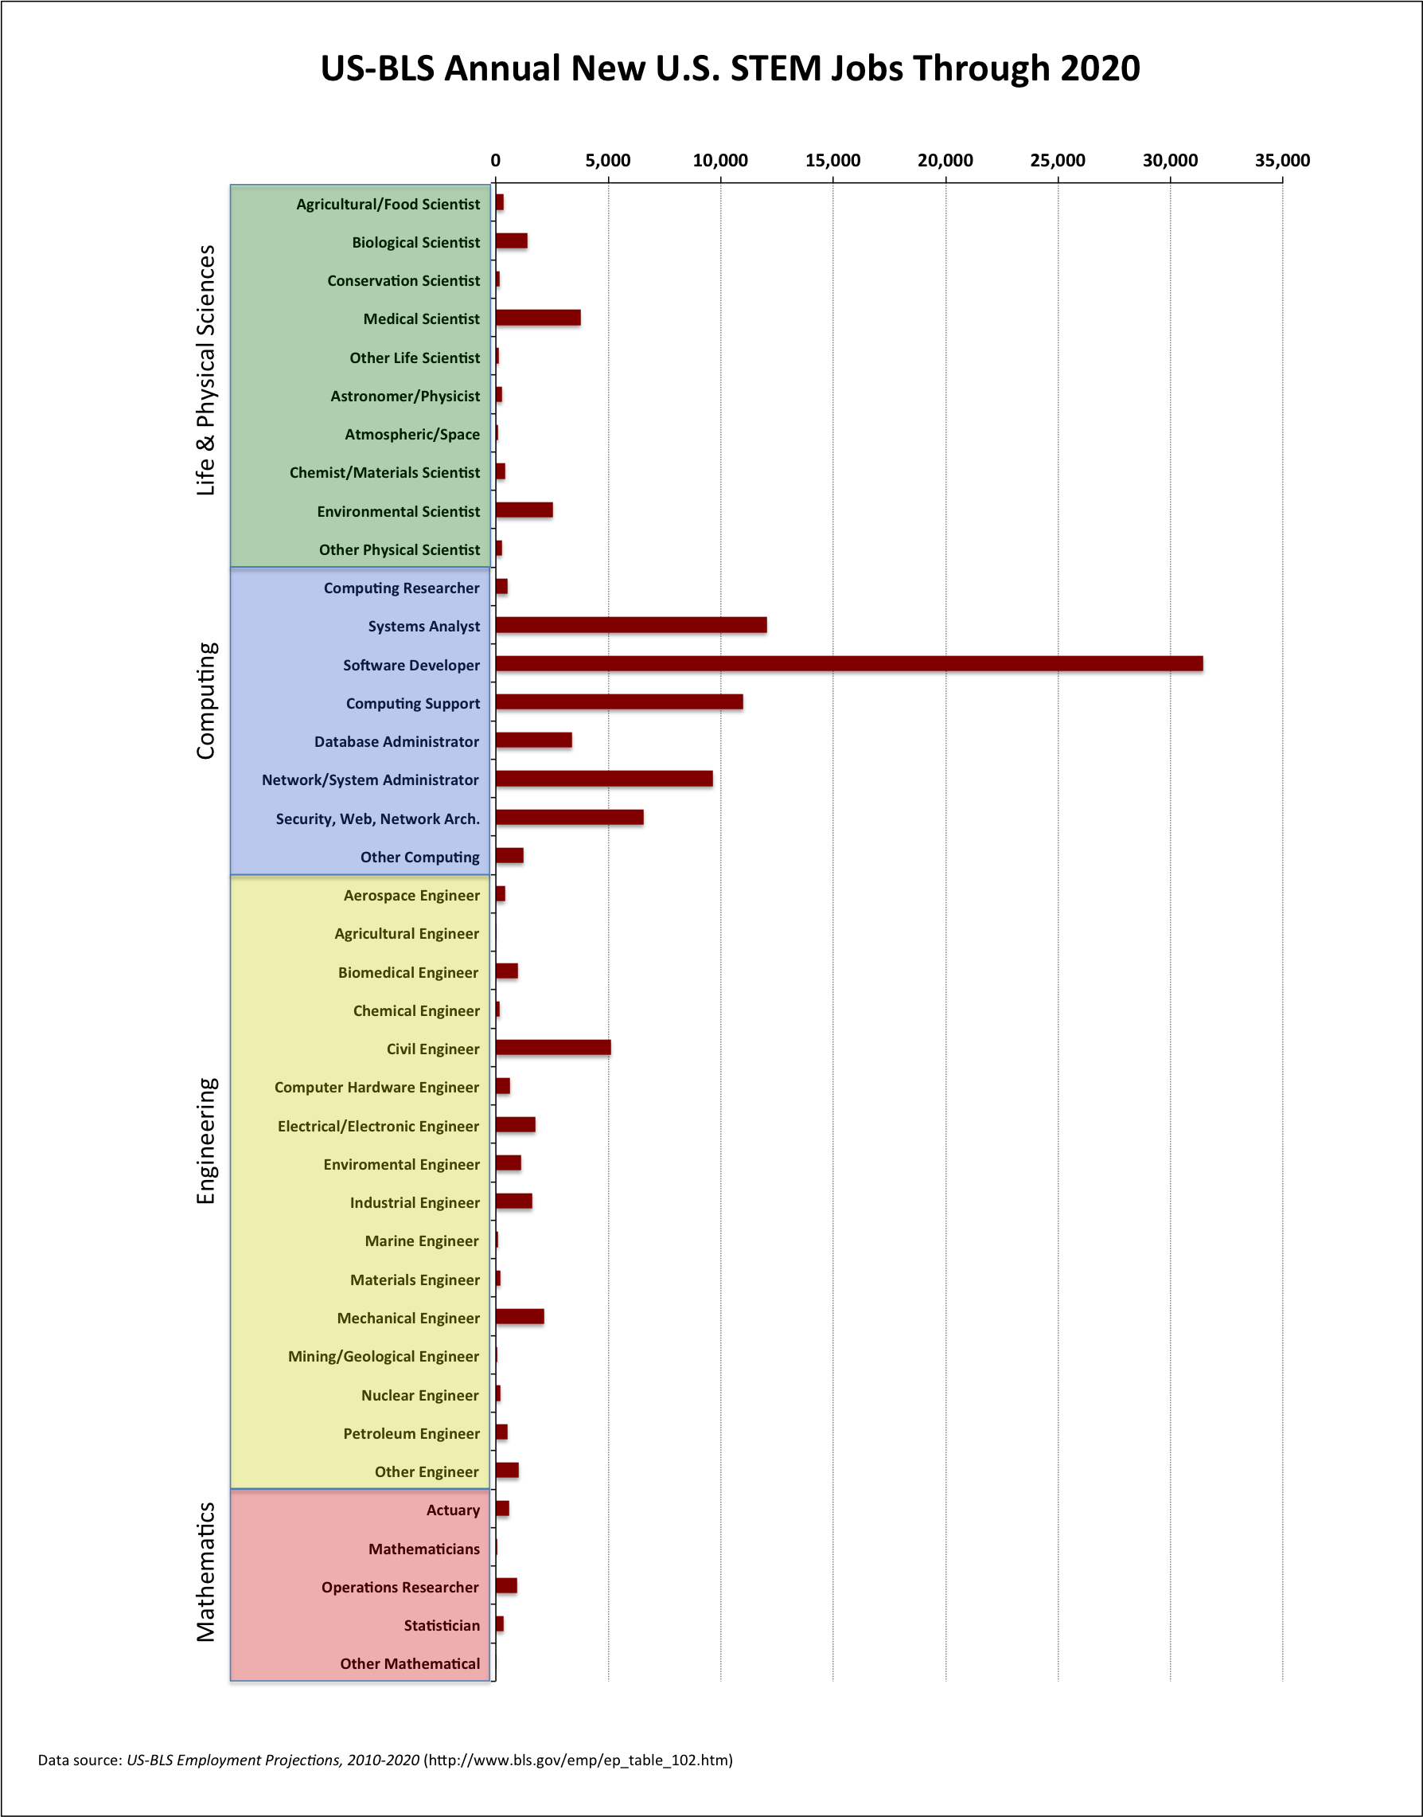

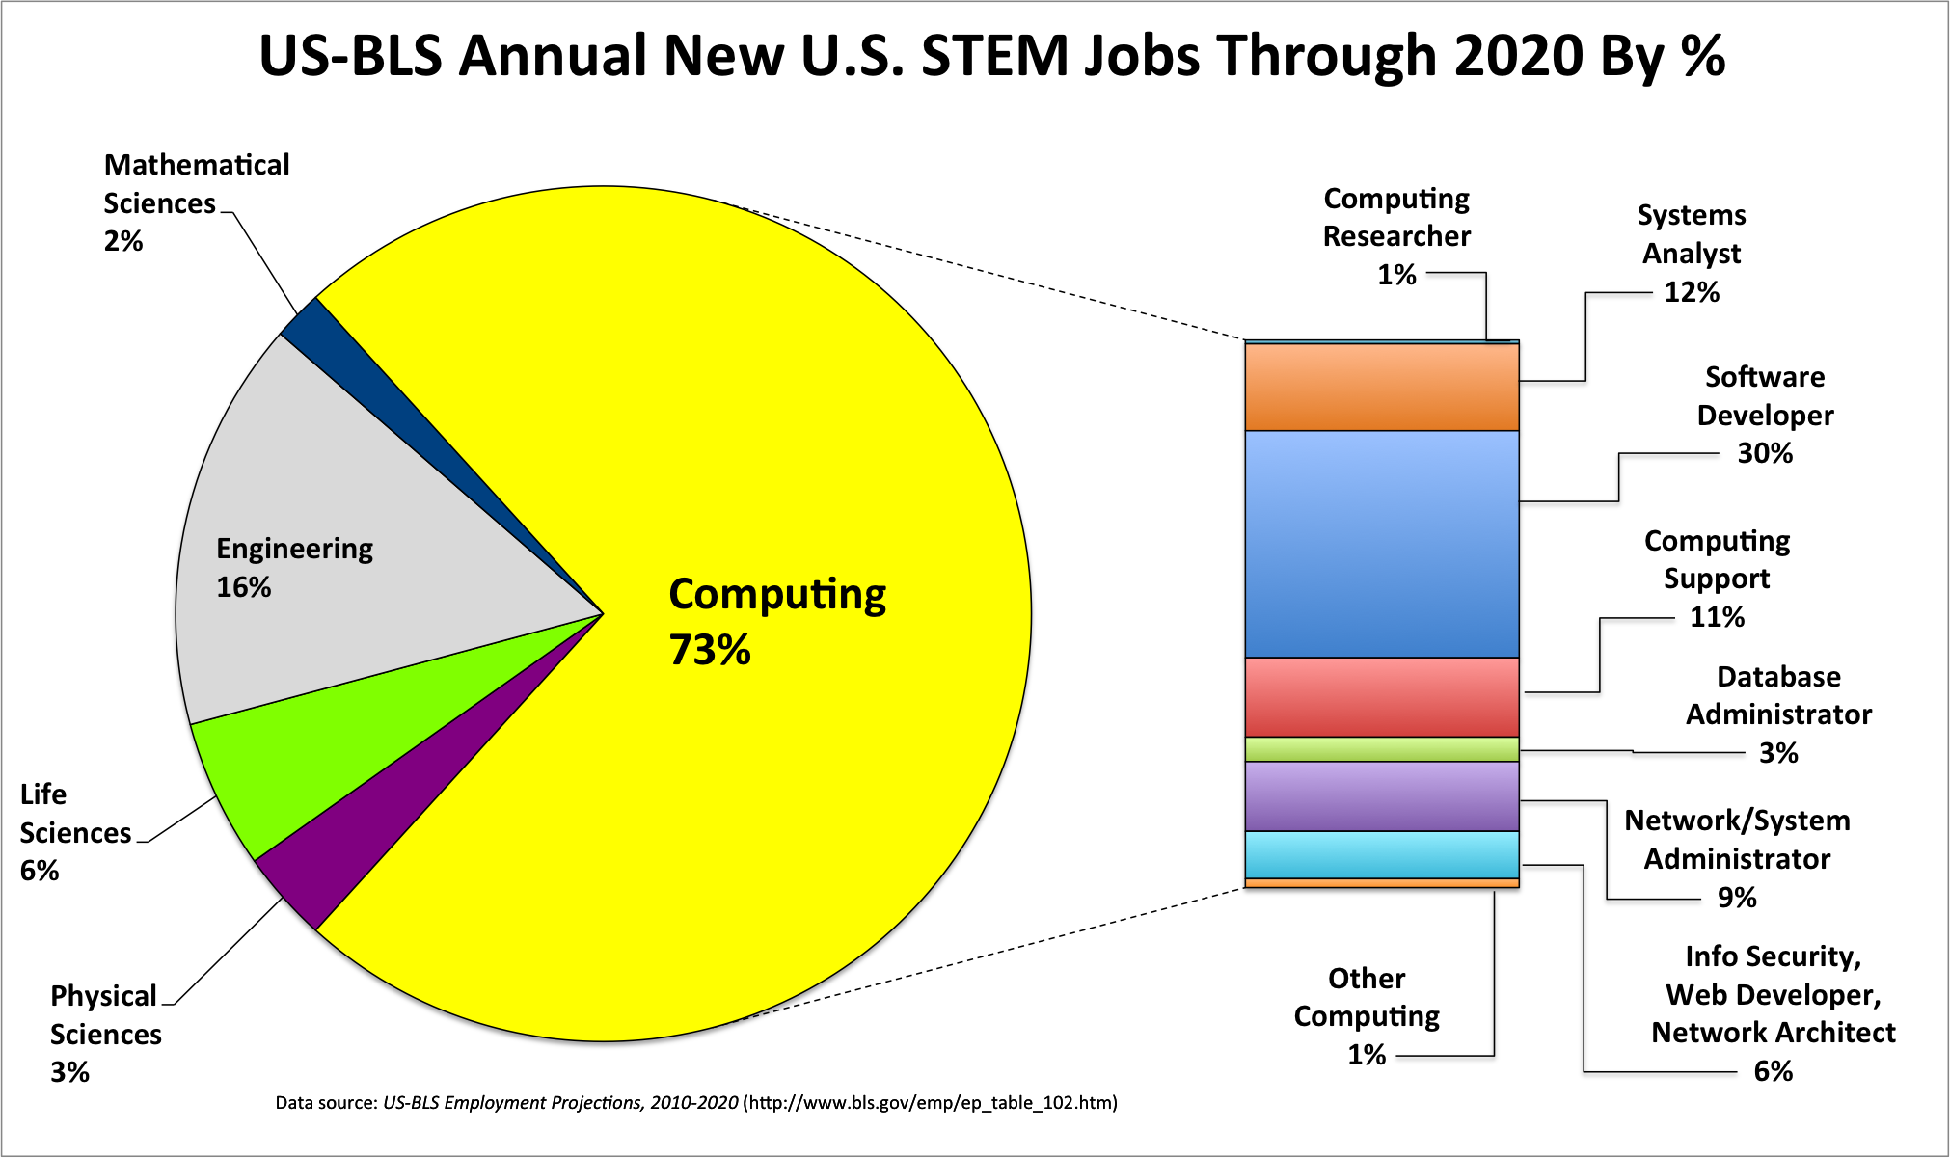

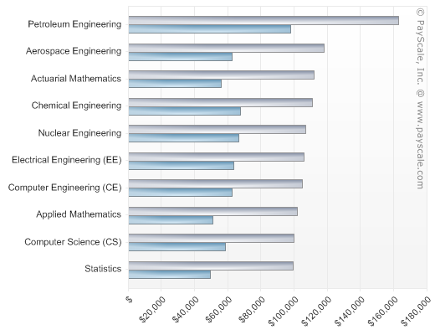

# What is Programming and C++

What is programming?

What is a programming language?

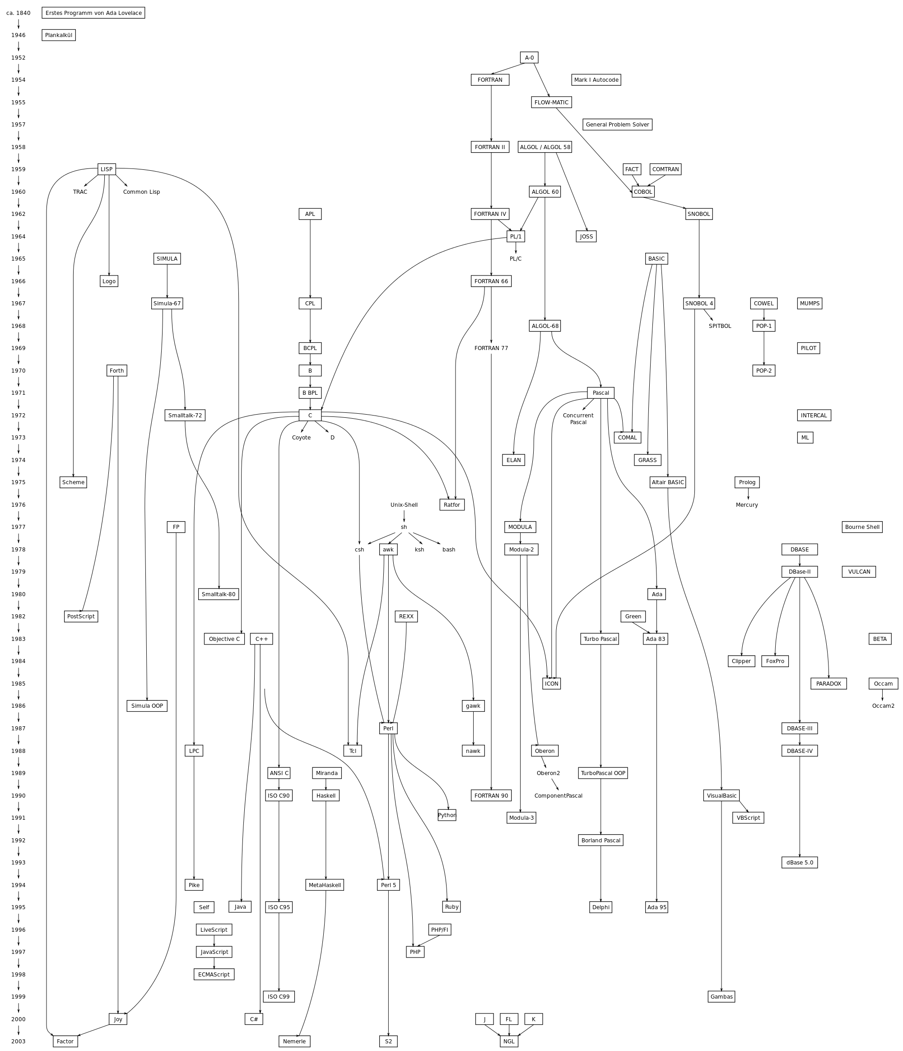

Hierarchical layers of programming languages

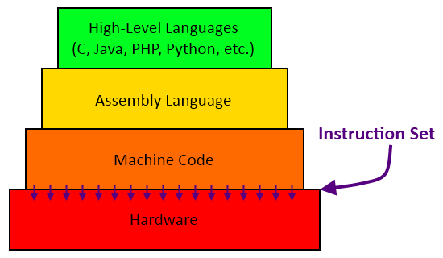

Why C++?

* Popular
* Object-oriented language
* Concise clear language
* Is a good language to first learn programming
* Portable

# Getting Started with C++

**Installing C++ in your computer:**

* We will use Eclipse but feel free to use any C++ editor.
* To install Eclipse search on YouTube “Install Eclipse for C++”, choose the appropriate video and follow directions.

**(Class Activity) Running the first program**

* Open Eclipse (or other editor like CodeBlocks)
* Create a new C++ project
* Create a new “HelloWorld.cpp” file
* Compile and run the file

|  |  |
| --- | --- |
| HelloWorld.cpp | Output |
| #include <iostream>  using namespace std;  int main(){  cout << "Hello World";  return 0;  } | Hello World |

**What happens when we build a C++ program?**

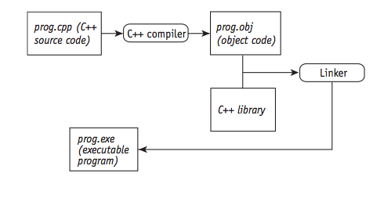

**A simple input-output C++ program**

|  |  |
| --- | --- |
| WhatIsYourName.cpp | Output |
| #include <iostream>  #include <string>  using namespace std;  int main ()  {  string mystr;  cout << "What's your name? ";  getline (cin, mystr);  cout << "Hello " << mystr << ".\n";  return 0;  } | What's your name? Andi  Hello Andi. |

**Testing, revising and optimizing a program**

